Iron Bird Test Facility for Urban Air Mobility System Development

The objective of this project is to develop an Iron Bird Test Facility (IBTF) setup for Urban Air Mobility System Development. The IBTF provides a ground-based test rig used for s are used for system integration, reliability test, shakedown testing of aircraft systems. The use of IBTF provides Hardware-in-the-Loop (HWIL) testing for comprehensive design testing and verification with the aim to reduce the number of flight test required during a drone system development. The HWIL allows different flight envelopes, operating scenarios and conditions to be repeatedly and fully investigated and tested so that the drone system under development can be fully understood prior to actual flight. Safety operational flight mission logics software such as geo-fencing safety templates, flight control failure handlings etc can be extensively tested using the IBTF. With sufficient simulation runs, the IBTF helps to generate test data in maximizing the safety gained from IBTF testing in order to predict trends or to find anomalous conditions before the actual flight test.

In this project, the team will work with Neo Aeronautics air mobility platform baseline (as shown in Figure 1) and derive an IBTF, through a systematic engineering approach as shown in Figure 2.

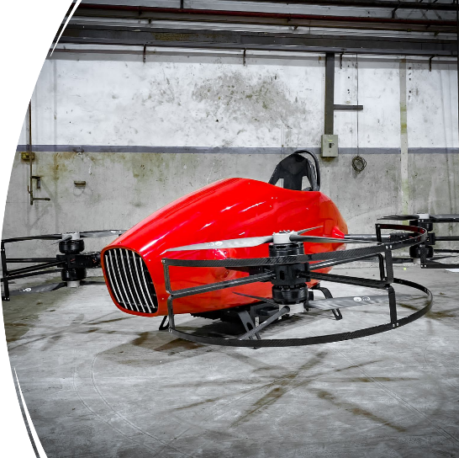

Figure 1: Neo Aeronautics Air Mobility Platform

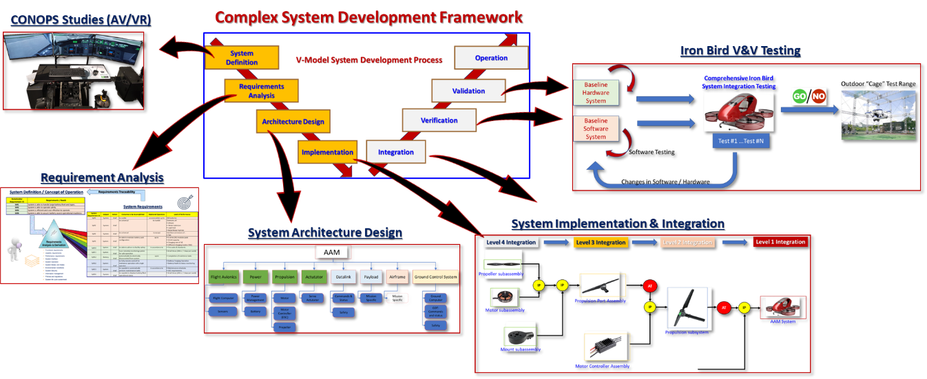

Figure 2: System Engineering development approach

The team will perform requirement analysis, system architecture design before moving to system implementation, integration and testing on a proof-of-concept POC to be developed. It is envisaged that the POC system will be developed in the DSO-SIT joint lab. Commercial off the shelves (COTS) autopilot system will be explored for the setup of the IBTF.

